# 2024 Global Population Data Analysis



# About the dataset

The dataset "2024Populations.csv" provides a comprehensive overview of global population statistics for 234 countries, with data spanning from 1980 to projections for 2050. Key columns include 'rank', 'country', 'TwoLetterID', 'unMember', and population figures for various years ('pop1980', 'pop2000', 'pop2010', 'pop2023', 'pop2024', 'pop2030', 'pop2050'). Additional columns such as 'landAreaKm', '2024YoYChange', '2024YoYGrowthRate', '2024WorldPercentage', and 'Density_2024' offer insights into land area, year-over-year population changes, growth rates, global population percentage, and population density.

From the sample data, we observe that India, China, the United States, Indonesia, and Pakistan are the top five countries by population rank in 2024. India leads with a projected population of approximately 1.44 billion, followed closely by China with 1.42 billion. The United States, Indonesia, and Pakistan have significantly lower populations but still rank high globally. Notably, India's population is growing at a rate of 0.91%, while China shows a slight decline of 0.03%. The dataset also highlights the vast differences in land area and population density, with India having a density of 484.91 people per square kilometer compared to China's 151.22.

Overall, this dataset provides valuable insights into global population trends, growth rates, and demographic changes, which are crucial for policy-making, economic planning, and understanding global demographic shifts.

# Relevant Inquiries

## How does the population density in 2024 vary among the top 10 most populous countries?

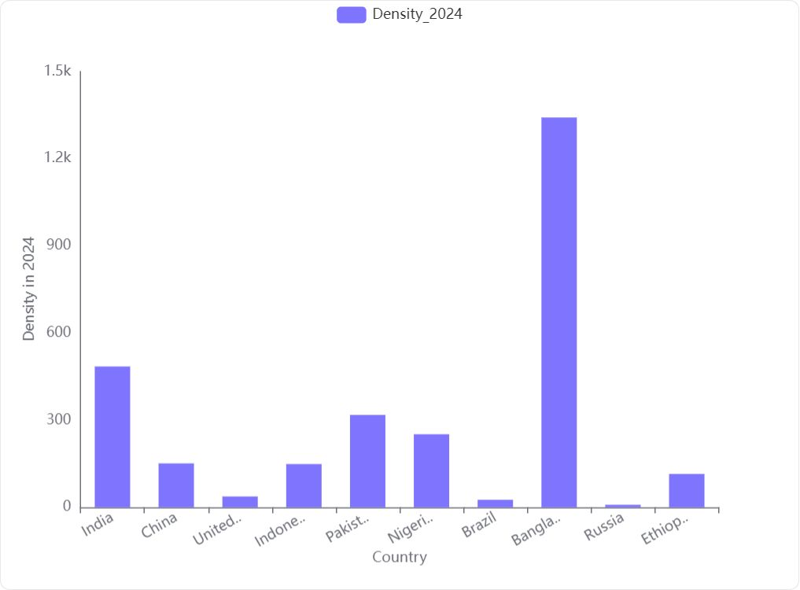

**Overview:** The population density in 2024 among the top 10 most populous countries exhibits significant variation, as depicted in the bar chart visualization. The density values range from very low to extremely high, indicating diverse living conditions and spatial distribution of populations across these nations.

**Key Observations:**

**High Variation in Density:**

* **Bangladesh** stands out with the highest population density, significantly higher than all other countries, indicating a very crowded living condition.
* **India** also shows a relatively high density, though it is significantly less than Bangladesh.
* **Pakistan** and **Nigeria** have moderate density values, suggesting somewhat crowded urban areas but less so than India or Bangladesh.
* **China**, **Indonesia**, and **Brazil** have lower densities, reflecting more land area per person.
* **United States**, **Russia**, and **Ethiopia** exhibit the lowest densities among the top 10, indicating large land areas with relatively sparse populations.

**Density and Land Area:**

* Countries like **Russia** and the **United States** have large land areas which contribute to their low population densities.
* Conversely, **Bangladesh**, with a much smaller geographical area, has a very high population density.

**Implications for Urban Planning and Infrastructure:**

* High-density countries may face challenges related to urban overcrowding, such as stress on infrastructure, housing, and public services.
* Countries with lower densities might focus on issues like transportation and efficient resource distribution across larger areas.

**Conclusion:** The population density in 2024 for the top 10 most populous countries varies widely, from extremely high in Bangladesh to very low in Russia. This variation impacts each country's approach to urban planning, infrastructure development, and resource management. Understanding these differences is crucial for tailored policy-making and sustainable development efforts in each nation.

## Which countries have experienced a negative year-over-year population change in 2024?

The analysis of the dataset reveals that **43 countries** have experienced a negative year-over-year population change in 2024. Below are the key details of the top five countries with the most significant population declines:

**China**

* **2024 YoY Change:** -492,570
* **2024 YoY Growth Rate:** -0.0003455
* **2024 World Percentage:** 17.5577%
* **Density in 2024:** 151.217 people per km²

**Russia**

* **2024 YoY Change:** -487,280
* **2024 YoY Growth Rate:** -0.00337348
* **2024 World Percentage:** 1.7735%
* **Density in 2024:** 8.79027 people per km²

**Japan**

* **2024 YoY Change:** -663,081
* **2024 YoY Growth Rate:** -0.00537803
* **2024 World Percentage:** 1.51077%
* **Density in 2024:** 336.437 people per km²

**Germany**

* **2024 YoY Change:** -42,159
* **2024 YoY Growth Rate:** -0.000506143
* **2024 World Percentage:** 1.02564%
* **Density in 2024:** 238.279 people per km²

**Italy**

* **2024 YoY Change:** -173,018
* **2024 YoY Growth Rate:** -0.00293895
* **2024 World Percentage:** 0.723134%
* **Density in 2024:** 198.493 people per km²

**Key Observations:**

* The countries listed have all seen a decline in their populations from 2023 to 2024.
* The population changes range from slight decreases (as seen in Germany) to more substantial reductions (as seen in Japan and China).
* These changes are significant as they impact the countries' demographics, potential economic growth, and global population distribution percentages.

**Further Analysis:**

* It would be beneficial to investigate the causes of these declines, such as lower birth rates, higher mortality rates, or increased emigration.
* Understanding the impact of these population changes on the economy, healthcare, and social services within these countries could provide deeper insights into potential future trends.

## How has the population of the top 5 most populous countries changed from 1980 to 2024?

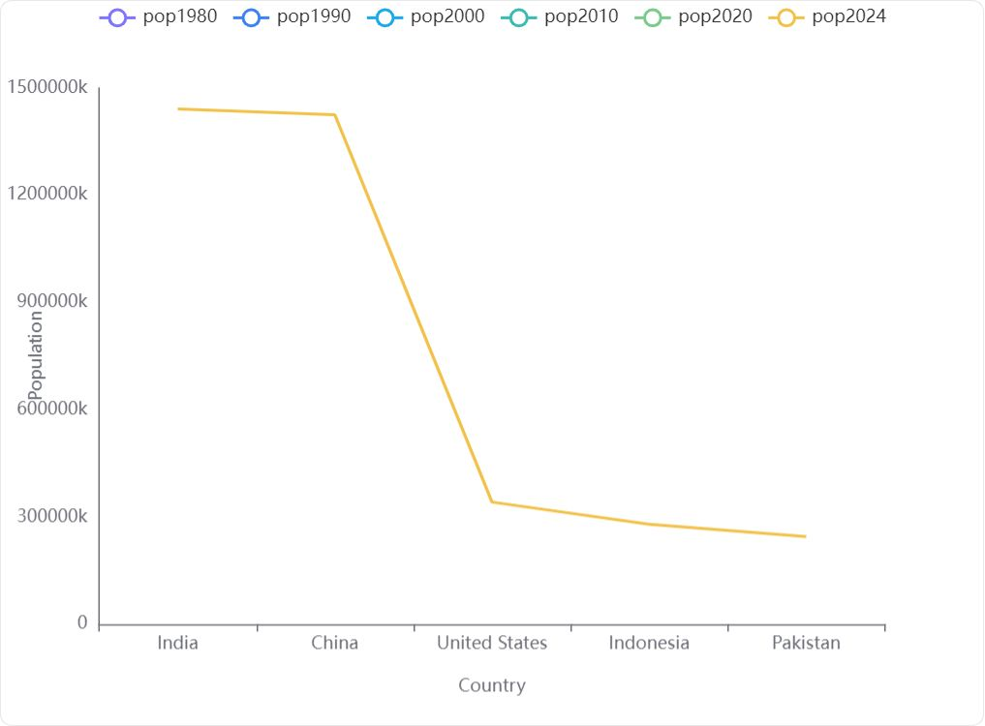

#### Overview

The analysis focuses on the population changes in the top 5 most populous countries from 1980 to 2024. These countries include India, China, the United States, Indonesia, and Pakistan.

#### Key Observations from Data

#### Visual Analysis

The line chart provided visualizes the population data for these countries from 1980 to 2024. However, it appears that the data for the years 1980, 1990, 2000, 2010, and 2020 are missing or not available, as indicated by the flat lines for these years. The only visible data point is for the year 2024, showing a sharp decline in population figures as we move from India to Pakistan.

#### Conclusion

* **India** remains the most populous country in 2024, closely followed by **China**.
* There is a substantial drop in population numbers from China to the **United States**, and further to **Indonesia** and **Pakistan**.
* The lack of historical data from 1980 to 2020 limits a comprehensive analysis of trends over the years. The provided chart only effectively shows the population status in 2024, indicating the relative sizes of the populations among these countries at that point in time.

**Recommendation**: To better understand the population trends and changes over the years, it is essential to obtain complete historical data for each of the countries from 1980 to 2020.

## How does the population growth from 2023 to 2024 compare between countries with large land areas and those with small land areas?

#### Key Findings:

* **Significant Difference in Growth**: There is a substantial difference in the population growth rates between countries with large land areas and those with small land areas from 2023 to 2024.
* **Population Growth in Large Land Area Countries**:
* **Mean Population Growth**: 610,418
* This indicates a **high growth rate** in countries with larger land areas.
* **Population Growth in Small Land Area Countries**:
* **Mean Population Growth**: 17,963.1
* This shows a **much lower growth rate** compared to their larger counterparts.

#### Conclusion:

The data clearly shows that **countries with large land areas are expected to experience significantly higher population growth** from 2023 to 2024 compared to countries with small land areas. This could be due to various factors including but not limited to more available space for habitation, potentially greater natural resources, and possibly different economic dynamics that support larger populations.

## What is the distribution of population densities across all countries in 2024?



#### Overview

The analysis of the population density across various countries for the year 2024 reveals a wide range of densities, indicating significant variation in how populations are distributed geographically. The data includes 234 countries with a mean density of 456.13 people per square kilometer and a high standard deviation of 1991.33, suggesting a large spread in the values.

#### Key Observations from Data

* **Mean Density**: 456.13 people per square kilometer
* **Standard Deviation**: 1991.33, indicating high variability
* **Minimum Density**: 0.14 people per square kilometer
* **Maximum Density**: 21674.22 people per square kilometer
* **Examples of Densities**:
* India: 484.907 people per square kilometer
* China: 151.217 people per square kilometer
* United States: 37.3673 people per square kilometer
* Indonesia: 149.025 people per square kilometer
* Pakistan: 318.091 people per square kilometer

#### Visualization Insights

The histogram visualization of population densities for 2024 shows:

* **High Frequency of Low Densities**: Most countries have relatively low population densities, clustering near the lower end of the density spectrum.
* **Few Outliers**: There are a few countries with extremely high population densities, as indicated by the spikes in the histogram. These outliers significantly exceed the general population density levels observed globally.

#### Conclusion

The population density distribution for 2024 is characterized by a majority of countries having low to moderate densities and a few outliers with extremely high densities. This distribution highlights the uneven spatial distribution of populations across different countries and regions. The high standard deviation confirms the significant disparities in how densely populated different areas of the world are projected to be.

## What percentage of the world's population does each country represent in 2024?

#### Key Findings:

* **India and China** dominate the global population in 2024, with India accounting for approximately **17.76%** and China for about **17.56%** of the world's population.
* The **United States** represents a smaller fraction, approximately **4.21%** of the global population.
* **Indonesia** and **Pakistan** also have significant shares, with **3.45%** and **3.02%** respectively.

#### Detailed Observations:

* The data provided includes population estimates for the year 2024 for 234 countries.
* The 'CalculatedWorldPercentage' column accurately reflects the percentage of the world's population that each country represents in 2024.
* The percentages range from very small (almost 0%) for countries with small populations like Vatican City, to significant percentages for populous countries like India and China.

#### Conclusion:

The calculated percentages in the 'CalculatedWorldPercentage' column provide a clear and precise representation of the proportion of the world's population that each country constitutes in the year 2024. This data is crucial for understanding demographic distributions and planning for global and national policies.

## Are there any countries that are not UN members, and how do their populations compare to UN member countries?

**UN Membership and Population Comparison**

* **Presence of Non-UN Member Countries**: Yes, there are countries that are not members of the United Nations.
* **Population Comparison**:
* **UN Members**: The average population for UN member countries in the year 2024 is estimated to be **41,418,730**.
* **Non-UN Members**: The average population for non-UN member countries in the year 2024 is significantly lower, estimated at **1,038,044**.

**Key Insight**: UN member countries, on average, have significantly larger populations compared to non-UN member countries by the year 2024.

## What is the correlation between land area and population density in 2024?

**Correlation Coefficient**: -0.0654821

**Interpretation**: The correlation between 'landAreaKm' and 'Density_2024' is **-0.0654821**, indicating a **very weak negative relationship**. This suggests that as the land area increases, the population density in 2024 slightly decreases, but the effect is minimal.

## Which countries have the highest and lowest population growth rates in 2024?

**Countries with the Highest and Lowest Population Growth Rates in 2024**

**Highest Population Growth Rate:**

* **Country:** Syria
* **2024 Year-over-Year Growth Rate:** **0.0482644 (4.83%)**

**Lowest Population Growth Rate:**

* **Country:** Moldova
* **2024 Year-over-Year Growth Rate:** **-0.0308697 (-3.09%)**

## What is the average population growth rate from 2023 to 2024 across all countries?

**Average Population Growth Rate (2023-2024):** The average population growth rate across all countries from the year 2023 to 2024 is **0.91%**.